Procedures For Processing New

TomTom Basemap Data

The following are step-by-step instructions on how to download the newest basemap data from TomTom and upload it onto the Server.

# Download and unzip

1. Begin by looking at the different DVDs provided. Get an idea of what data is on which DVD. For some data, there will be two DVDs, one with the geographic data and a separate one for related documentation.
2. Open Windows Explorer and create a new year (i.e. 2012) folder in G:\Data\TANA.
3. In that folder:
   1. Create a new folder named *dvdContents.*

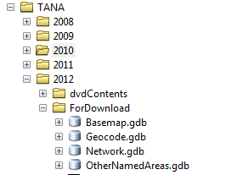

* 1. In *dvdContents:*
     + 1. Create a *zippeddata* folder and an *unzippeddata* folder.
       2. For each DVD, create a folder in both the zipped/unzipped directories:

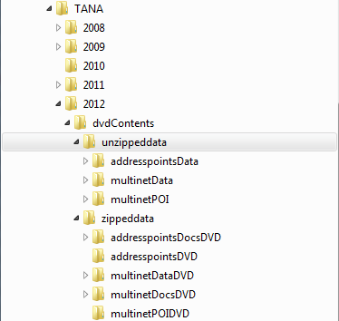

1. For each DVD with geographic data on it*:*
   1. Copy the contents of the DVD to its “zippeddata” folder on the G:\drive.
   2. This will take a while. Once it is done copying, select the folder in Windows Explorer.

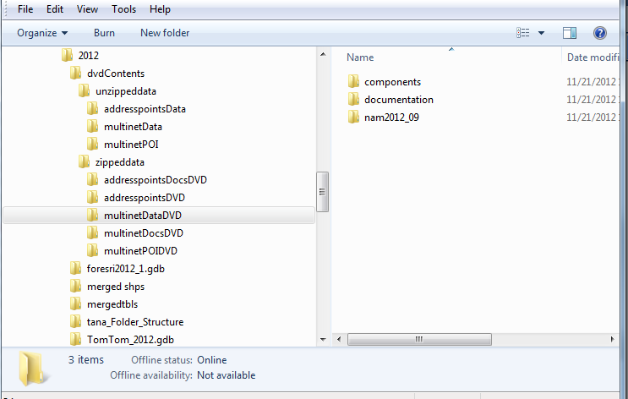

* 1. In the search box, type in “*.gz”
  2. All geographic zip files from that DVD should be returned.
  3. Select all the files returned in the search by selecting one, and then pressing Ctrl+A:

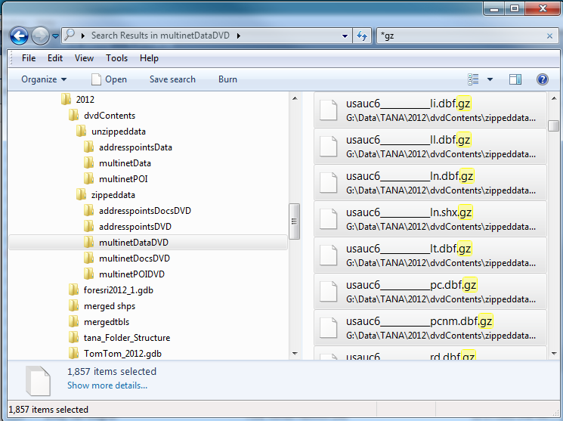

* 1. Right-click the selection and use **7Zip** to *Extract files…*
  2. Choose the *unzippeddata* DVD folder to extract the files to, match the other settings below, then press OK:

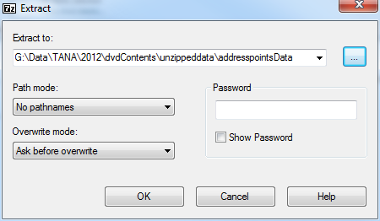

multinetData

* 1. This may take some time. Once you have extracted the files from all Data DVDs, you will have to merge and rename the shapefiles. This is due to the fact that TomTom splits data for California into 6 sections, so all the shapefiles are broken up and need to be merged into one state shapefile. For 2012 the sections are indicated by “usauc1” “usauc2” all the way to 6:

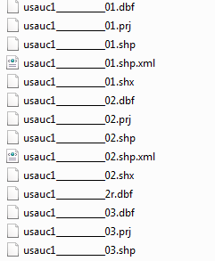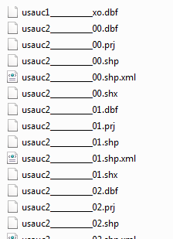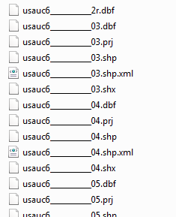

* 1. But before merging the shapefiles, take a look at one of the xml files. If it does not have the real metadata in it for the shapefile, then you will have to run the delete_xml.bat file in G:\Scripts\TANA Scripts, and then copy over the real metadata files from the Documentation DVD.
     1. In the Command Prompt, navigate to the directory with all the unzipped data.
     2. Run the delete_xml.bat file.
     3. It will show you a list of all the files it is about to delete. Type upper case Y to continue and delete these XML files. Type N to cancel out.

1. Copying over metadata files for the shapefile data from the Documentation DVD:
   1. On the Docs DVD, go to: \components\mn\fgdc\xml\usa and copy the contents of “uc1-6”, and “usc” folders to their “zippeddata\…DocsDVD” folder on the G:\drive.
   2. Once done copying, select the “zippeddata\…DocsDVD folder on the G:\drive in Windows Explorer.

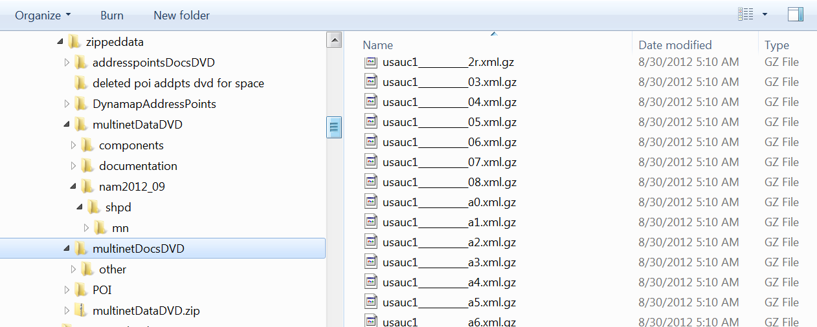

* 1. In the search box, type in “*xml.gz”
  2. All metadata xml zip files from that DVD should be returned.
  3. Select all the files returned in the search by selecting one, and then pressing Ctrl+A:
  4. Right-click the selection and use **7Zip** to *Extract files…*
  5. Choose the *unzippeddata* DVD folder to extract the files to (you can create a special folder to put these in), match the other settings below, then press OK:



multinetData

* 1. Additionally, it seems that ESRI requires the metadata to be named *ShapefileName.shp.xml.*
  2. This year, 2012, the TomTom metadata came in this format: *ShapefileName.xml.*
  3. You will need to run a script in XYplorer to add *.shp* to the file names, so that ESRI software will identify it as metadata.
     1. Open XYplorer and navigate to the directory with the xml files.
     2. Select ONLY the xml files you want to rename in the window below.
     3. Click the Tools menu and go to Run Script.
     4. Copy the following line into the window:

rename e, "shp.xml";

* + 1. Press OK to rename the xml files.
  1. If you created a separate folder for these files make sure to move them back into the folder with the shp data.

# Organizing the Data for Processing

1. Once you have extracted all geographic data into the respective DVD folders, you must organize the data for merging and renaming the shapefiles. This consists of running a few batch files which will create a folder structure to organize the shapefile and tabular data.
2. Copy the createFileList.bat and TanaFolderMoveData.bat from G:\Scripts\TANA Scripts into the unzipped DVD folder that has all the shapefile and tabular data. Change the properties so they are no longer Read-Only.
3. The first batch file you will be working with is createFileList.bat. Its contents are:

if exist filelist.txt (del filelist.txt)

for %%y in (usauc*.dbf) do (@echo %%~ny >> filelist.txt)

It is designed to get all of the unique dBase file names from the directory which have a *usauc* prefix. If the prefix for the shapefiles is different for your year, you will have to edit the batch file and replace *usauc* with the new prefix. Some state shapefiles only have a section 2 and 3 shapefile, so using a wildcard (*) after *usauc* ensures that all unique names will be extracted. There will be duplicate listings but this is okay.

Once you have made any necessary adjustments to the script, run it.

1. It will create a text file in the same directory called filelist.txt. Open up the text file. It should look like this:

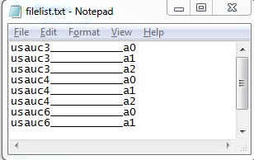

1. Do a find and replace (Ctrl+H) and get rid of all the prefixes on the files, i.e., do a find for “usauc1___________” and replace all with a null string. Then repeat for all six section numbers.

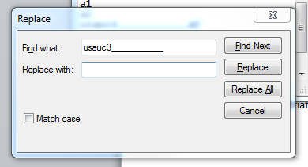

1. The result will be a list with the appropriate shapefile names in it. As stated before, the names are duplicated, but this is necessary to catch all files (the next batch file will deal with this):

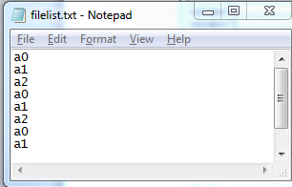

1. Close the text file.
2. Next we will be working with the batch file that creates directories and organizes the shapefiles into their corresponding folders based on filelist.txt.
3. Right click and edit TanaFolderMoveData.bat. Its contents are:

for /F %%x in (filelist.txt) do (

if not exist ".\%%x" (

mkdir %%x

move "usauc*___________%%x."* ".\%%x"

))

If the prefix is different, change it in the batch file and save before running. The if statement takes care of the duplication of filenames in the text file.

1. Double-click the batch file to run it. A new folder will be created for each unique state-wide shapefile and all of the associated files will have been moved to their respective folders:

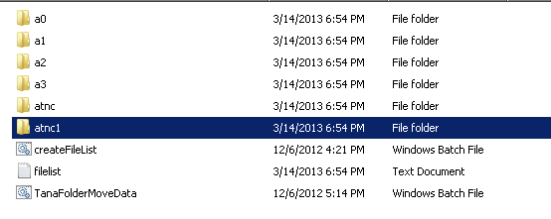

If this did not happen, perhaps you needed to change the prefix in the batch file, or clean up the filelist.txt.

**Move tabular data to a new directory:**

1. Now we will need to move the tabular data to a different location for processing separately.
2. Create a “**tables**” folder in the unzipped DVD folder. If you name it something different, you must change it in the batch file below.
3. You will now run the TanaFolderMoveTbls.bat file, which is this:

FOR /F %%x IN (filelist.txt) DO (if not exist ".\tables\%%x" (if not exist ".\%%x\*.shp" (mkdir ".\tables\%%x"

move ".\%%x\*" ".\tables\%%x\")))

**The script uses the filelist.txt to create directories for all the folders that don’t contain geographic data (shapefiles). Then it will move all the data from those folders to the new directories under “tables”. The old table folders in the parent directory won’t be deleted, but they are now emptied of table data.

# Merge Tables and Shapefiles

**Merge Shapefiles:**

* + - 1. Now you have completed the data organization and are ready to run the Merge Tables and Merge Shapefiles geoprocessing tools.



* + - 1. Open up ArcCatalog
      2. Connect to or navigate to G:\Data\Database Connections\mtcgis4\Spatial Modeling Tools on mtcgis4.sde\mtcgis.spatial_models.TANATools.

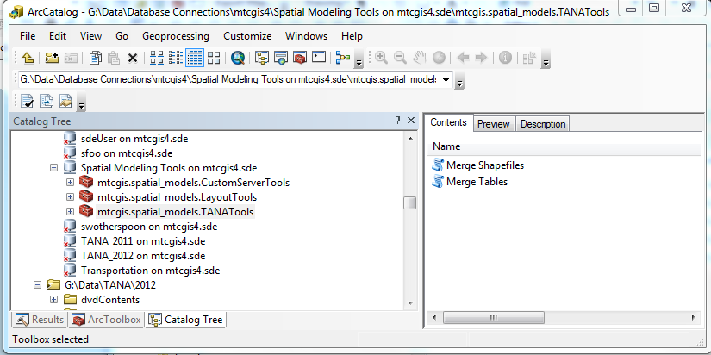

* + - 1. Double-click the Merge Shapefiles Tool. 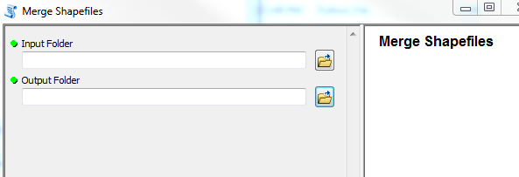
      2. For Input Folder put the folder that holds all of the shapefile folders, or the parent folder.
      3. For Output Folder, create a new folder for the output merged shapefiles to go before you load them to the server geodatabase. DO NOT put it under the directory you are using for “Input Folder” as the program will be looping through all directories in that folder.

**This cannot be a geodatabase because the inputs are shapefiles.

* + - 1. Run the tool, (this will take a while, best to do it overnight), and when it is done, you will have a directory of all the merged shapefiles.
      2. Because we will be importing these shapefiles into a geodatabase, the streets (00-08) layers must be renamed so they don’t start with a number. The convention that will be used is “**streets_00**” for all of these layers. This is also important for running the tool that will create the TANA geodatabases for the Data Portal downloads.

**Merge Tables:**

1. Do the same thing for the tabular data, using the Merge Tables tool, also in G:\Data\Database Connections\mtcgis4\Spatial Modeling Tools on mtcgis4.sde\mtcgis.spatial_models.TANATools.
2. For the Input Folder, choose your “**tables”** folder with all of the tables directories in it. Create another folder for the output merged tables.
3. The Merge Tables tool accepts dBase files but not csv. If the merge does not work on a particular folder, it will show an error in the Results window, but it will continue to run through the rest of the folders in the directory. At the end of the Results, it will print out a list of folders that did not merge successfully so you may look into why this occurred and fix it.

# Import Feature Classes and Tables to Server

* + - 1. You will need permission to import data and create a user on the server for the following steps.
      2. Create a new user/database connection using ArcToolbox. Look under Data Management Tools, Geodatabase Administration for the Create User Tool.
      3. Once you have created the user, navigate to the database connection file and open the connection for the User that will be the owner of the data.
      4. Right-click and Import Feature Class (multiple). Choose all of the data you’d like to upload, one DVD at a time. You will want to check for duplicate file names while importing. Do the Multinet DVD **last**. If there are duplicate names between the DVDs, put an “mn” prefix in front of all Multinet data that is a duplicate.

# Create the TANA zip files for Data Portal downloads:

1. In your new year (i.e. 2012) folder in G:\Data\TANA, create a new folder named ForDownload.



The TANA data is organized into four categories for download: **Basemap, Geocode (GC), Network,** and **Other Named Areas(OA)**. The feature classes to be included in each category are listed out in a series of four text files located in: *G:\Scripts\TANA Scripts\TextFiles*:



Inside the file:

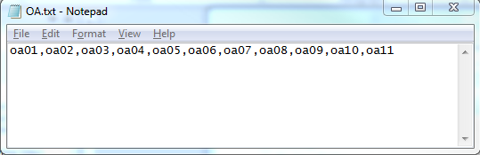

To change the layers included in a geodatabase, simply remove them from the list and save. You may also add new layers to the existing text file, so long as you follow the convention above, separating each shapefile name by a comma. There should be no carriage returns in the text file.

1. Now you will run a python script to create a new geodatabase. The tool creates a new geodatabase for the category chosen, then it clips all of the shapefiles listed in the chosen text file to the Bay Area, and outputs them into the new geodatabase.

*If you need to add a category or want to name the new geodatabase something other than is provided in the list, simply go to the properties for the tool and add your new category to the list of values for that parameter.

1. The tool is located in G:\Data\Database Connections\mtcgis4\Spatial Modeling Tools on mtcgis4.sde\mtcgis.spatial_models.TANATools, and is called “**RegionalClipForDownload**”. Double-click the tool and see that your inputs are similar to those below:

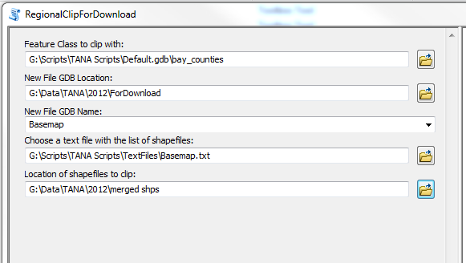

1. The default clipping feature class is bay_counties. This is the nine-county Bay Area including the water.
2. Choose your **ForDownload** folder to put the new GDB in.
3. Choose which category you are processing first. This is also going to be the name of the geodatabase to be created.
4. Choose the text file with the list of feature classes to be clipped and copied.
5. Choose the **merged shps** directory to point the program to the location of all of the shapefiles to be clipped.
6. Repeat the process for the other three categories.
7. Once you are done running the tool, zip up the geodatabases into their own zip files and upload them to the Data Portal server for download.

**END**